**Bhavya Sharma Task-1.**

**What is artificial intelligence?**

The broad field of artificial intelligence encompasses the use of technologies to create computers and machines that can replicate cognitive processes associated with human intelligence, including seeing, comprehending, and responding to spoken or written language, analysing data, making recommendations, and more.

Simple Example: Have you ever noticed how quickly you can identify your friend's face in a photo? AI is also capable of that! Like you, it can recognise faces from thousands of photos.

AI in real life that you use on a daily basis:

* When Netflix suggests films that you might enjoy.
* When the camera on your phone automatically focusses on faces.
* When Google Maps determines the most efficient path for you.
* When Alexa or Siri comprehends what you're saying.

## What is machine learning?

Machine learning, essentially, represents a branch within artificial intelligence where systems are designed to learn and adapt autonomously. Rather than relying on detailed, manual programming, these systems are exposed to large datasets, from which they identify patterns and extract insights. Over time, this process enables them to refine their functions and enhance decision-making capabilities based on accumulated experience.

Example:

Imagine instructing a child to identify a cat. Rather than providing an exhaustive list of criteria, you present a series of images: “This is a cat, here’s another cat, and this one isn’t a cat.” Gradually, the child discerns the distinguishing features—perhaps whiskers, pointed ears, or the characteristic meow.

**The Relationship Between AI and ML**

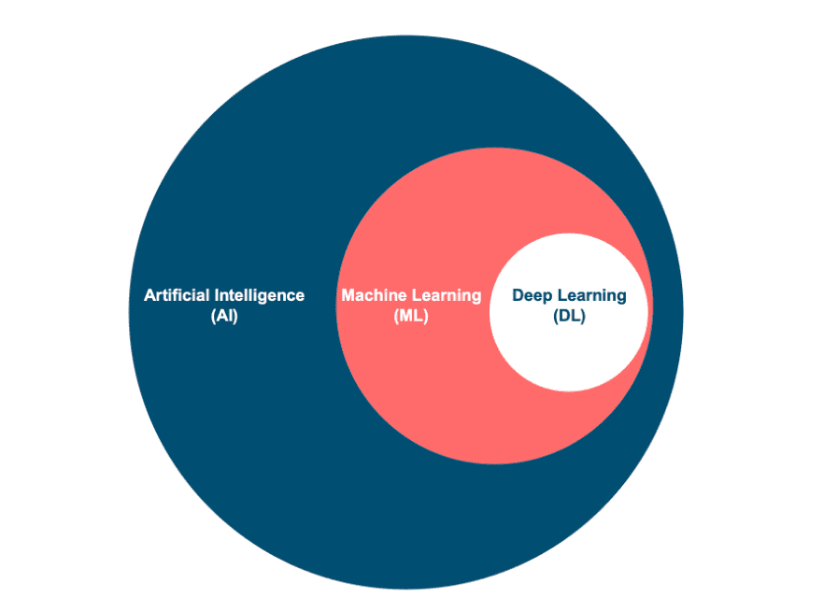

| **Aspect** | **Artificial Intelligence (AI)** | **Machine Learning (ML)** |
| --- | --- | --- |
| **Core Purpose** | AI allows a machine to simulate human intelligence to solve problems | ML allows a machine to learn autonomously from past data |
| **Primary Goal** | To develop an intelligent system that can perform complex tasks | To build machines that can learn from data to increase the accuracy of the output |
| **How It Works** | We build systems that can solve complex tasks like a human | We train machines with data to perform specific tasks and deliver accurate results |
| **Scope of Applications** | AI has a wide scope of applications | Machine learning has a limited scope of applications |
| **Technology Used** | AI uses technologies in a system so that it mimics human decision-making | ML uses self-learning algorithms to produce predictive models |
| **Data Types Supported** | AI works with all types of data: structured, semi-structured, and unstructured | ML can only use structured and semi-structured data |
| **Learning & Correction Method** | AI systems use logic and decision trees to learn, reason, and self-correct | ML systems rely on statistical models to learn and can self-correct when provided with new data |

**Simple way to think about it:**

AI = The destination (making computers smart).

Machine Learning = The vehicle (how we get there).

Deep Learning = A fancy, powerful vehicle.

**Types of Machine Learning (Simplified)**

1. **Supervised Learning:**

In supervised learning, the computer is provided with labeled data—essentially, examples accompanied by the correct answers. Through repeated exposure to these labeled .

Examples, such as thousands of images marked as “cat” or “dog,” the algorithm learns to distinguish between categories in new, unseen data.  
Practical applications include email spam detection, medical diagnosis via imaging, and automatic speech recognition

1. **Unsupervised Learning:**

Unsupervised learning involves supplying the computer with unlabeled data and allowing it to identify patterns or groupings independently.

For instance, when analyzing customer purchasing behavior, the algorithm might infer that individuals who buy diapers often purchase coffee as well, revealing trends without explicit instruction.  
This approach is frequently utilized for customer segmentation, anomaly detection (such as identifying fraudulent transactions), and organizing complex datasets.

1. **Reinforcement Learning:**

Reinforcement learning is modeled after trial-and-error learning. Here, the computer interacts with an environment, taking actions and receiving feedback in the form of rewards or penalties. Over time, the algorithm refines its strategy to maximize positive outcomes.  
Notable applications include game-playing artificial intelligence (e.g., AlphaGo), autonomous vehicle navigation, and the development of more adaptive conversational agents.

**What is a Machine Learning Pipeline?**

A machine learning pipeline operates much like an assembly line in a factory; instead of manufacturing cars, it “manufactures” predictive models. In a car factory, you begin with raw steel, shape and paint it, assemble the parts, conduct quality checks, and, at the end, you have a finished vehicle.

Translating that process to machine learning: you start with unrefined, raw data. This data is first cleaned to remove noise and inconsistencies. The next step involves training a model on this processed data, followed by rigorous testing to ensure the model is functioning as intended. If the model passes these tests, it is then deployed to generate predictions.

In summary, a machine learning pipeline can be defined as a systematic sequence of steps that transforms disorganized data into a functional artificial intelligence system capable of making informed predictions.

**The 7 Steps of ML Pipeline:**

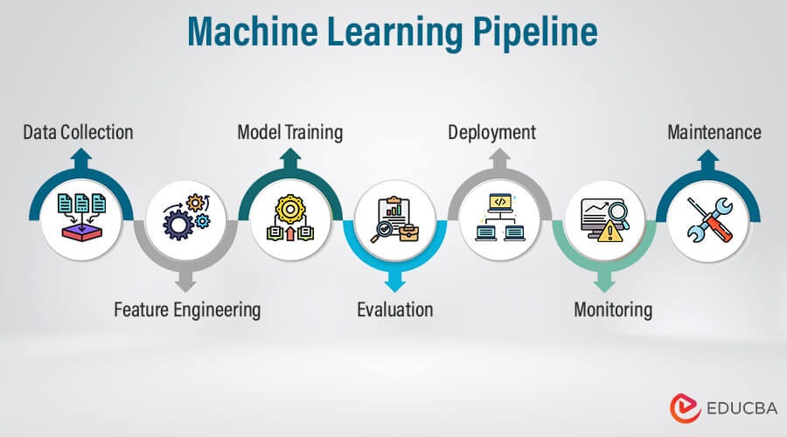

**Step 1: Data Collection**To begin, it’s essential to gather all relevant information. Think of this as assembling the necessary ingredients before cooking—flour, eggs, milk, and so on. Without collecting these foundational elements first, the process cannot proceed effectively. Systematic data collection ensures a solid basis for any subsequent analysis or action.

**Step 2: Data Cleaning**

In essence, data cleaning involves correcting errors, addressing missing values, and eliminating irrelevant information from your dataset. Imagine it like preparing ingredients before a scientific experiment—removing impurities and ensuring everything is in optimal condition. By refining your data in this way, you lay a solid foundation for reliable analysis and accurate results.

**Step 3: Data Preparation**

At this stage, the goal is to transform raw data into a format suitable for computational analysis. Here’s what typically happens:

- Textual information is converted into numerical representations, as algorithms require numbers, not words.

- All numerical values are scaled to similar ranges, ensuring that no single variable disproportionately influences the model.

- New, relevant features may be engineered to help the model uncover patterns more effectively.

- The dataset is divided into training and testing subsets—training for model learning, testing for evaluating performance.

A fitting analogy might be meal preparation in a professional kitchen: ingredients are measured, chopped, and organized before cooking begins. This careful upfront work lays the foundation for a successful outcome**.**

**Step 4: Model Training 🎓**

At this stage, the focus shifts to enabling the computer to detect and interpret patterns within the data. Think of it as instructing a student to distinguish between various animals by repeatedly presenting labeled images—through repetition, the student gradually learns to recognize and classify each one.

There are several foundational approaches for model training.

Linear Regression seeks straightforward, linear relationships within the data. Decision Trees operate by posing a series of yes/no questions, systematically narrowing down possibilities.

Neural Networks, inspired by the architecture of the human brain, utilize interconnected layers to process complex information and capture subtle patterns.

Each methodology offers unique strengths depending on the nature and complexity of the dataset at hand.

**Step 5: Model Testing**

At this stage, the model’s performance is evaluated using data it hasn’t encountered before. The key metrics of interest are:

- Accuracy: How frequently does the model make correct predictions?

- Error Rate: When mistakes happen, how significant are they?

- Reliability: Does the model perform consistently across different data sets?

This process is analogous to taking a practice exam after studying, to gauge readiness for the real test. If the model does not perform adequately during testing, it may be necessary to revisit earlier steps:

- Return to Step 4: Adjust training methods or experiment with alternative strategies.

- Go back to Step 3: Improve data preparation, perhaps by refining data selection or feature engineering.

- Re-examine Step 2: Enhance data cleaning to ensure higher quality inputs.

By systematically evaluating and refining these aspects, the goal is to develop a model that demonstrates robust and reliable performance on new, unseen data.

**Step 6: Model Deployment**

At this stage, the model transitions from development to practical application. Essentially, it is the process of introducing a trained model into a real-world environment for end users to interact with and benefit from its predictions. An apt analogy would be a chef finally opening a restaurant after perfecting their signature dish—now the public can actually experience and evaluate the results.

There are several primary modes of deployment:

- **Web Application:** This approach enables users to interact with the model through a website, as seen with platforms like Zillow’s home price estimator.

- **Mobile Application:** Here, the model operates within a mobile app, allowing users to obtain predictions directly from their smartphones—commonly used in real estate or financial applications.

The overall objective is to bridge the gap between model development and end-user utility, ensuring that the predictive capabilities are accessible, scalable, and reliable within the intended deployment context.

**Step 7: Monitoring & Maintenance 🔧**

At this stage, ongoing oversight of the model is essential. The process involves tracking performance metrics to ensure predictions remain accurate. When new data becomes available, integrating it is crucial to maintain relevance. If there’s a noticeable drop in performance, retraining the model is warranted. Additionally, addressing bugs and implementing feature improvements are standard procedures.

A practical analogy: think of it like vehicle maintenance. Just as cars require regular oil changes, tire rotations, and prompt repairs to function optimally, machine learning models benefit from continuous attention and timely updates to sustain their effectiveness.

**What are Classifiers (Classification):**

Classification, in the context of machine learning, refers to the process by which a computer system is trained to distinguish among categories or groups within a dataset. Think of it as analogous to organizing laundry into different piles or categorizing music by genre—essentially, it’s about systematic grouping based on shared characteristics.

In summary, classification is a foundational technique in machine learning, facilitating the automated sorting of data into clearly defined categories based on learned patterns.

**The 3 Primary Forms of Classification Problems**

**1. Binary Classification**

This is the most straightforward format: the system must make a decision between two distinct categories. It functions much like a basic yes/no or true/false scenario.

Illustrative Example – Email Spam Detection:

Consider an email with phrases such as, “Congratulations! You won $1,000,000! Click here now!” The algorithm evaluates features such as:

- Presence of the word “Congratulations”

- Mention of a monetary amount

- A call-to-action like “Click here”

- Frequent use of exclamation marks

Based on these indicators, the email would be classified as SPAM

**2. Multi-class Classification**

Here, the problem involves more than two possible categories, but the system must select only one category per instance. This is typical in scenarios where each input clearly belongs to a single group out of several.

Common Examples:

- Animal identification: Cat, Dog, Bird, Fish

- Movie genres: Comedy, Action, Drama, Horror

- Academic grades: A, B, C, D, F

- Weather types: Sunny, Cloudy, Rainy, Snowy

- Modes of transportation: Car, Bus, Train, Bike

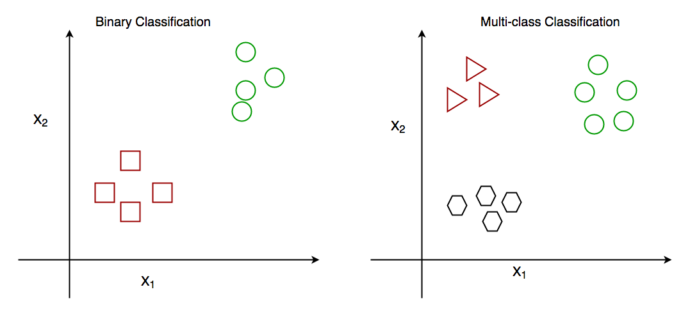

**3. Multi-label Classification**

In this scenario, each instance can belong to multiple categories simultaneously. This approach is often used when tagging or categorizing items that naturally fit more than one label.

Typical Applications:

- Movie tags: Films may be classified as both “Action” and “Comedy”

- News articles: One article could be tagged as “Politics” and “Economics”

- Photographs: An image may contain “Person,” “Car,” and “Building”

- Music genres: A piece can be labeled as “Rock,” “Classical,” and “Guitar”

In summary, these three types—binary, multi-class, and multi-label classification—form the foundational structures for categorizing data within machine learning. Each serves a distinct purpose depending on the nature of the data and the requirements of the task.

**Types of Classification Algorithms: Approaches to Machine Learning**

In the realm of machine learning, there exist multiple methodologies for instructing computers to categorize data. The choice of algorithm often depends on the complexity and nature of the problem at hand.

**Linear Classifiers**

Linear classifiers operate by establishing a straight boundary between categories within the data space. For instance:

- **Logistic Regression** identifies the optimal linear separator between two groups.

- **Linear SVM** seeks the maximum margin, or widest “road,” between groups to enhance classification robustness.

- **Perceptron** provides a fundamental approach to linear separation.

These models are particularly effective for problems where a clear, linear distinction exists between categories. They are commonly employed in tasks such as email spam detection and basic forms of medical diagnosis.

**Non-Linear Classifiers**

Conversely, non-linear classifiers are capable of constructing more complex, non-linear boundaries that better capture intricate relationships within the data. Notable examples include:

**- Decision Trees**, which use a sequence of binary questions to partition data.

- **K-Nearest Neighbors**, which classifies instances based on proximity to labeled examples.

- **Kernel SVM**, an extension of SVM that allows for non-linear boundaries via kernel functions.

- **Naive Bayes**, which leverages probabilistic reasoning for classification.

These algorithms are well-suited for scenarios where linear separation is inadequate, such as image recognition or complex medical diagnostics.

In summary, the selection between linear and non-linear classifiers depends largely on the underlying data structure and the complexity of the classification task.